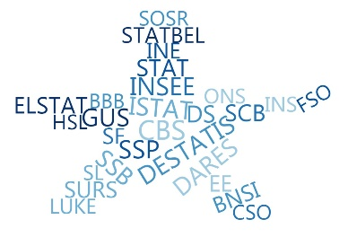

**ESSnet Big Data II**

**Grant Agreement Number:**

**NUMBER — 847375 — 2018-NL-BIGDATA**

<https://webgate.ec.europa.eu/fpfis/mwikis/essnetbigdata>

[<https://ec.europa.eu/eurostat/cros/content/essnetbigdata_en>](https://ec.europa.eu/eurostat/cros/content/essnetbigdata_en)

**Workpackage WPB**

**Implementation – Online Job Vacancies**

**Developing meaningful indicators based on OJA data**

state of date: 24th August 2020

|  |
| --- |
| **Prepared by: Martina Rengers (DESTATIS, Germany)** |

Workpackage Leader:

Tomaž Špeh (SURS, SI)

e-mail address: tomaz.speh@gov.si

mobile phone: +38651672116

Developing meaningful indicators based on OJA data

**Table of contents**

1. Examples of institutions and companies dealing with OJAs 3

2. Timeliness, short-term development, early detection of turning points: the case of COVID-19 outbreak and initial OJA figures for March 2020 9

3. Structural analyses 14

4. Literature 16

Appendix 17

**Table of figures**

Figure 1: OJAs used in labour market reporting by public-law / non-profit institutions (selection) 4

Figure 2: OJAs (commercially) collected and analysed by private companies (selection) 6

Figure 3: Australia: First page of the monthly report of Internet Vacancy Index (IVI) 7

Figure 4: USA: First page of the monthly report of Help Wanted Online (HWOL) Index 8

Figure 5: Burningglass US: Free access to timely data in the situation of Covid-19 10

Figure 6: Indeed Hiring Lab: Free access to timely data in the situation of Covid-19 (first page) 11

Figure 7: LinkedIn: How COVID-19 is impacting hiring around the world 12

Figure 8: Textkernel: Free access to timely graphs in the situation of Covid-19 13

Figure 9: Germany: how to interpret the different OJA indicators from selected private companies using the example of Covid-19 14

Figure 10: USA: Opportunity Insights Economic Tracker – Percent Change in weekly unique job postings by states 17

Figure 11: USA: Opportunity Insights Economic Tracker – percent change in weekly unique job postings as time series 18

Figure 12: Swiss Job Market Monitor: overall index and channel-specific sub-indices regarding specific recruiting channels 18

Developing meaningful indicators based on OJA data

# Examples of institutions and companies dealing with OJAs

Figure 1 shows a selection of indicators based on OJA data used in labour market reporting separated by public-law or other non-profit institutions. It gives an overview regarding the answer to the question „what do the others do in the world“, and provides first ideas about meaningful indicators based on OJA data.

For example, the Australian government publishes an index of ***monthly*** online job advertisements. The database is based on the three largest job portals in Australia (SEEK, CareerOne and Australian Job Search). Figure 4 shows the first page of this monthly report of Internet Vacancy Index (IVI). Its development is presented from 2006 onwards. Not only an index value is calculated (index: January 2006 = 100), but also monthly absolute figures on the new job ads received within a month are shown. Additional information is the percentage change of the previous month and previous year. A differentiation is also made according to occupations, qualification requirements and 37 regions.

In the United States the member driven think tank The Conference Board uses data collected from online job sources including traditional job boards, corporate boards, and social media sites. Results are published on a monthly basis as shown in Figure 5. However, not evident at first sight, the reference period is defined as mid-month of previous month to mid-month of reference month that means data is aggregated from the 14th of the previous month to the 13th of the current month. The reason for this is the comparison of this labour demand with the labour supply based on unemployment figures of the Bureau of Labor Statistics (BLS). The latter one are collected with the so-called Current Population Survey which is a monthly survey that uses as reference period in general the calendar week (Sunday through Saturday) that includes the 12th day of the month (mid-month survey). [1]

The most recent important development is the so-called **real time economic tracker** from Opportunity Insights, an American organisation based at Harvard University (see Figure 2). This tracker has many different indicators and is more or less an immediate consequence of the COVID-19 pandemic, which has significantly increased the already existing pressure to use alterna­tive new digital data sources. Chetty et al. build „a new, freely accessible platform that tracks economic activity at a **high-frequency, granular level** using anonymized and aggregated data from private companies. […] We report these statistics in real time using an automated pipe­line that ingests data from businesses and reports statistics publicly on the data visualization platform, typically less than **seven days** after the relevant transactions occur.“ [2]

One can get further ideas from exploring private companies, which collect and analyse OJAs. Figure 3 lists the six most famous companies: Burning Glass, Haver Analytics, Gartner Inc., Indeed Hiring Lab, LinkedIn and Textkernel. Not mentioned in Figure 3 is the Swiss company x28 AG as it only covers one European country, the Switzerland itself. Furthermore, publications regarding their Jobradar[3] are only available after contact details have been entered.

Figure 1: OJAs used in labour market reporting by public-law / non-profit institutions (selection) – part 1

|  |  |  |  |
| --- | --- | --- | --- |
| **Country** | **Institution** | **Indicators** | **Data basis** |
| **Australia** | Australian government  [*http://www.ga.gov.au/*](http://www.ga.gov.au/) | **Name:**  Internet Vacancy Index (IVI) <https://data.gov.au/dataset/internet-vacancy-index>  and  <http://lmip.gov.au/default.aspx?LMIP/VacancyReport>  **Periodicity**:  monthly press releases  (see Figure 4)  **Timelag:**  22 days after the end of e.g. corona month March 2020 | 3 biggest job portals (SEEK, CareerOne and Australian JobSearch);  Data provision by Department of Jobs and Small Business <https://www.jobs.gov.au/> |
| **Austria** | Austrian Public Employment Service (AMS) , a public service provider [*http://www.ams.at/*](http://www.ams.at/%20) *\** | **Name:**  Qualifikationsbarometer [*http://bis.ams.or.at/ qualibarometer/*](http://bis.ams.or.at/qualibarometer/)  not very prominent subdomain of [www.ams.at](http://www.ams.at)  **Periodicity:**  half a year (mostly) / yearly | Until reporting year 2015 job ads from print media – no ads from online job portals;  From reporting year 2016 onwards job ads from online job portals; automated data collection and data processing by using the big data platform **Jobfeed** powered by the company Textkernel [*https://www.jobfeed.com/at/home.php*](https://www.jobfeed.com/at/home.php)  See also: [*https://www.textkernel.com/hr-software/jobfeed/*](https://www.textkernel.com/hr-software/jobfeed/%20) |
| **Europe** | CEDEFOP  [*https://www.cedefop.europa.eu*](https://www.cedefop.europa.eu) | * **OVATE** (Online vacancy analysis tool for Europe) data presentation platform <https://www.cedefop.europa.eu/en/data-visualisations/skills-online-vacancies> * **Skills Panorama** data presentation platform <https://skillspanorama.cedefop.europa.eu/en/indicators/skills-online-vacancies> | Job advertisements from different job portals in Europe collected by web scraping, crawling or API.  For more details see CEDEFOP (2019), CEDEFOP (2018a). Country-specific reports are available at: <https://www.cedefop.europa.eu/en/publications-and-resources/country-reports/online-job-vacancy-market> (e.g. CEDEFOP 2018b). |
|  | EUROSTAT  [*https://ec.europa.eu/eurostat/web/main*](https://ec.europa.eu/eurostat/web/main) | Future plans. | Future plans:  Online platform “Data science lab” created as joint system together with CEDEFOP.  See the paper from Descy et al. (2018) presented at the DGINS Conference "The European path towards Trusted Smart Statistics" in Bucharest 2018. |
|  | European Central Bank ECB  [*https://www.ecb.europa.eu*](https://www.ecb.europa.eu) | **Name:** High-frequency data developments in the euro area labour market:   * Indeed job postings indicator * LinkedIn hiring rate indicator * nowcasting of unemployment rate during Covid-19 based on two above mentioned timely data sources   **Periodicity:**  Irregular**  **Time lag:**  Approximately 20 days after last observation day | Daily job postings from Indeed in the period from 2017 till 20 June 2020 for DE, FR, IT, ES, NL  Beyond pure job posting data they used additional information from the jobportal LinkedIn, in this case the so called LinkedIn hiring rate indicator calculated as the percentage of LinkedIn members who started  a job on a given day of the month and added a new employer to their profile in that month, divided by the total number of LinkedIn members in the five countries considered (DE, FR, IT, ES, NL).  See ECB (2020). |

* Not available in English

**These publications are a result of the urgent high frequency data needs to assess the impact of Covid-19 (see also Chapter 2).

Source: Translated, updated and expanded from Rengers (2018).

Figure : OJAs used in labour market reporting by public-law / non-profit institutions (selection) – part 2

|  |  |  |  |
| --- | --- | --- | --- |
| **Country** | **Institution** | **Indicators** | **Data basis** |
| **Germany** | Ifo Institute,  a registered non-profit association  [*https://www.ifo.de*](https://www.ifo.de) | **Name:** Press release June 16th 2020 based on findings of a joint evaluation by the ifo Institute and the LinkedIn social network  [*https://www.ifo.de/en/node/56091*](https://www.ifo.de/en/node/56091)  **Periodicity:**  Irregular** | Change in the number of job ads in different industries in the period from March-May 2019 to March-May 2020 measured as a proportion of all job ads on LinkedIn.  See Ifo Institute (2020). |
| **Switzer-land** | Swiss Job Market Monitor University of Zurich  [*https://www.stellenmarkt monitor.uzh.ch/en.html*](https://www.stellenmarktmonitor.uzh.ch/en/indices/combined.html%20) | Adecco Swiss Job Market Index (ASJMI)  [*https://www.stellenmarktmonitor.uzh.ch/de/indices/asjmi.html*](https://www.stellenmarktmonitor.uzh.ch/de/indices/asjmi.html)*  or  [*https://adeccogroup.ch/de/studien/job-index/*](https://adeccogroup.ch/de/studien/job-index/)  **Periodicity:** quarterly | The index is made up of three sub-indices that provide information on the change in job offers in the press, on company websites and on Internet job portals.  Regarding the job portals, those cross-industry and cross-professional Internet portals are taken into account which are most frequently used by companies for job advertisements. The identification of these most frequently used job portals is based on an annual company survey.  See Sacchi (2008). |
|  |  | Combined print-online index [*https://www.stellenmarktmonitor.uzh.ch/en/indices/combined.html*](https://www.stellenmarktmonitor.uzh.ch/en/indices/combined.html%20)  **Periodicity:** annual; last reference year 2014 | The combined print-online index shows the long-term development of demand for staff in Switzerland since 1950.  Web scraping of 12 job portals and 1,350 enterprise websites (for more details see Sacchi 2014*) |
| **USA** | Opportunity Insights,  an organization based at Harvard University  <https://opportunityinsights.org/> | **Name:** Oportunity Insights Economic Tracker  (real time economic tracker with a lot of different indicators)[*https://tracktherecovery.org/*](https://tracktherecovery.org/)  Regarding OJA:  Change in weekly unique job postings indexed to January 4-31 2020 (see Appendix Figure 11)  **Reference Period:**  a week ending Friday  **Periodicity:** weekly  **Timelag:**  3-5 days after end of working week | Data on job postings from 2007 to present from Burning Glass Technologies. Data from approximately 40,000 online job boards in the United States were collected and aggregated from Burning Glass.  See Chetty et al. (2020), especially chapter II.D. |
|  | The Conference Board,  a member-driven think tank  [*https://www.conference-board.org/*](https://www.conference-board.org/%20) | **Name:**  The Conference Board Help Wanted OnLine (HWOL) [*https://www.conference-board. org/data/helpwantedonline.cfm*](https://www.conference-board.org/data/helpwantedonline.cfm)  **Periodicity:**  monthly press releases (see Figure 5)  **Reference period:**  14th of previous month to 13th of following reference month  **Timelag:**  27-37 days after the end of a reference period , e.g. | Help Wanted Advertising Index (HWI) of print ads was published for over 55 years and discontinued in 2008; since 2005 indexmeasures changes over time in advertised online job vacancies Help Wanted OnLine (HWOL);  Situation in August 2018: More than 16,000 online sources;  Since December 2018: revised HWOL index based on 28,000 different online job boards including traditional job boards, corporate boards, social media sites, and smaller job sites that serve niche markets and smaller geographic areas AND since December 2018 release of experimental HWOL Index  Data delivery from the company Haver Analytics [*http://www.haver.com*](http://www.haver.com); cooperation with Wanted Analytics *www.wantedanalytics.com* which belongs to the American Company CEB *www.cebglobal.com* since November 2015; CEB itself was taken over by Gartner, Inc. *www.gartner.com* in April 2017.  Changes since 2019: Burning Glass Technologies |
|  | US State California:  EDD Employment Development Department  <https://edd.ca.gov> | HWOL statistics  <http://www.labormarketinfo.edd.ca.gov/data/help-wanted-online%28hwol%29/> | See descriptions in the row above regarding the conference board. |

* Not available in English

**These publications are a result of the urgent high frequency data needs to assess the impact of Covid-19 (see also Chapter 2).

Source: Translated, updated and expanded from Rengers (2018).

Figure 3: OJAs (commercially) collected and analysed by private companies (selection)

|  |  |  |  |  |
| --- | --- | --- | --- | --- |
| **Company** | **URL/ registered office** | **Observed country** | | **Product names** |
| **Burning Glass** | <https://www.burning-glass.com/>  Boston, USA    <https://www.burning-glass.com/uk/>  Edinburgh, United Kingdom    <https://www.burning-glass.com/au/>  Christchurch, New Zealand | In principle, this analysis tool can be used for any country. For the time being, the following case studies are available:     * Australia and Asia * USA: Missouri Economic Research Information Center * USA: Northeastern University * USA: University of Maryland, Baltimore County * United Kingdom: Company Active Informatics as official sales partner of Burning Glass | | * Labour Insight TM   For free:  Some news and results from labour market (OJAs) are available online; see Chapter 2 |
| **Haver Analytics** | [http://www.haver.com](http://www.haver.com/)  New York, USA | * Australia * Canada * China * Europe | * Japan * New Zealand * United Kingdom * USA |  |
| **Gartner, Inc.** | [www.gartner.com](http://www.gartner.com/)  Headquarter in Stamford (Connecticut), USA    German locations in Munich, Düsseldorf and Frankfurt am Main | * worldwide active | | * Gartner TalentNeuron TM (previous: Wanted Analytics) |
| **Indeed Hiring Lab** | <https://www.hiringlab.org/>  Indeed, Inc.  Austin, USA | * Australia * Canada * France | * Germany * Ireland * United Kingdom * USA | * analyses based on indeed’s own job portal   For free:  Some news and results from labour market (OJAs) are available online see Chapter 2 |
| **LinkedIn** | <https://economicgraph.linkedin.com>  https://www.linkedin.com/news/daily-rundown/ | * Europe *(new; coverage unclear)* * India * United Kingdom * USA | | * Economic graph   For free: monthly LinkedIn Workforce Report; monthly report on hiring, skills, and migration trends in the U.S., the U.K., and India. Also updated news as irregular web population;  see Chapter 2. |
| **Textkernel** | [https://www.textkernel.com](https://www.textkernel.com/)  Amsterdam, Netherlands  London, UK  Düsseldorf, DE  Paris, FR | Data for Europe and North America:   * Austria * Belgium * Canada * France * Germany | * Italy * Netherlands * Spain * United Kingdom * **USA** | * Jobfeed   DE: <https://www.jobfeed.de>  US: <https://us.jobfeed.com>  …  For free: weekly update of OJAs development for the most countries mentioned in the left column in graphs (see Chapter 2)  Apart from that:  No press releases with results from jobfeed (only demo versions can be requested) |

Source: Translated, updated and expanded from Rengers (2018).

Figure : Australia: First page of the monthly report of Internet Vacancy Index (IVI)

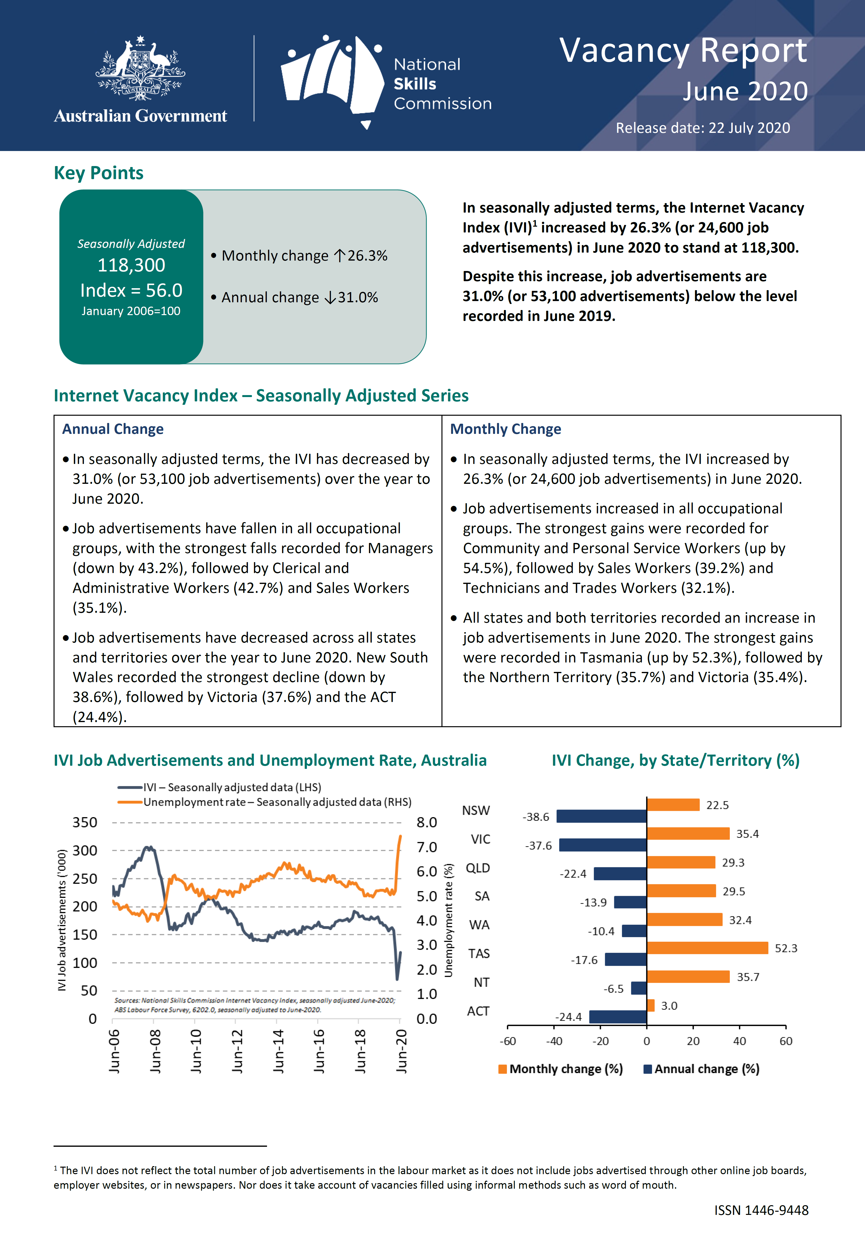

Source: Australian Government (2020); pdf document of the website <https://lmip.gov.au/default.aspx?LMIP/GainInsights/VacancyReport> (state of date: 18 August 2020).

Figure : USA: First page of the monthly report of Help Wanted Online (HWOL) Index

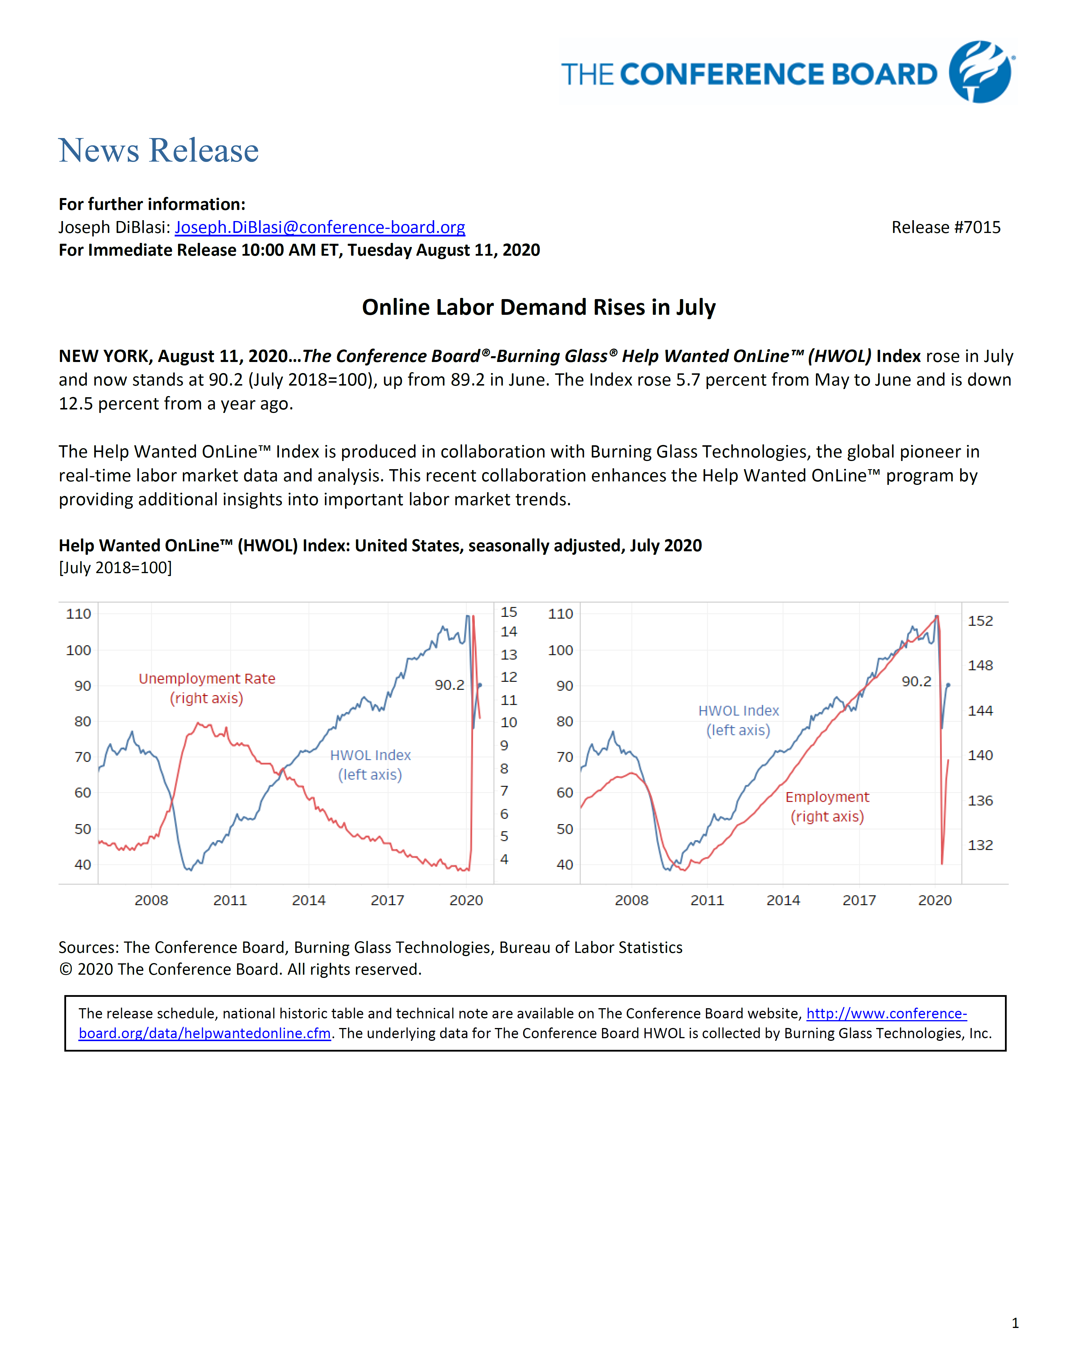

Source: <https://conference-board.org/pdf_free/press/7015%20-%20HWOL%20July%202020.pdf> (state of date: 18 August 2020)

# Timeliness, short-term development, early detection of turning points: the case of COVID-19 outbreak and initial OJA figures for March 2020

With a monthly index on the (economic) development of online job advertisements, the potential of real-time information from job portals can be analysed and processed in real time. Additional regional differentiations as well as job-group specific evaluations of the online job market provide new short-term indicators that show current and policy-relevant developments with regard to changes in the demand for labour. For example, early warnings of threatening bottlenecks or overcapacities are conceivable. In this way, information can be provided that goes beyond the established labour demand statistics.

In the following, the importance of real-time information from online job portals will be discussed in light of the current extraordinary COVID-19 crisis. Companies like Burningglass, Indeed, LinkedIn, and Textkernel react with very timely publications and information on special online sites. The earliest of these was Burningglass US, which, just four days after the end of a reporting week, provided calendar-week-specific changes to online job advertisements in an Excel file for download on a COVID-19 special page for all states of America (see Figure 6). They promote this with the following words: “The coronavirus pandemic has had an unprecedented impact on the world economy. Burning Glass Technologies is using its database of more than a billion current and historical job postings to measure this economic shock and how it affects the job market. We’ll be updating this page frequently with the latest data.”[4] Corresponding COVID-19 special pages from Indeed, LinkedIn, and Textkernel are shown in Figure 7, Figure 8 and Figure 9.

Timeliness and punctuality are one side of the coin, but what about data quality (e.g. coverage problem and problem of duplicates) and how to interpret the different OJA indices? In Figure 10 latest OJA data for Germany published by Textkernel and by Indeed are compared with each other. Textkernel’s product Jobjeed offers an overview of new job vacancies appearing on the Internet – at least that’s how the company describes it. But how exactly are "new job vacancies" defined? What is the reference period? Regarding the first graph of Figure 10 one can assume that the reference period is one calendar week. This indicator from Textkernel shows more or less a decline from March 01 to April 01 of around –40%. Unfortunately, there are no figures available for free but regarding the graph one can assume for calendar week 9 (including first of March 2020) an amount of 270K new jobs and for calendar week 14 (including first of April 2020) round about 160K. On the other side, the Indeed Index (measured as 7 day moving average of job postings on Indeed job portal) fell by 12% from March 1 to April 1.

Figure : Burningglass US: Free access to timely data in the situation of Covid-19

|  |
| --- |
| Including monthly results already 4 days after the end of the month (here: March 2020 available on 2020 April 6th) |
|  |

Source: <https://www.burning-glass.com/research-project/covid-19/> (state of date 02 April 2020)

Figure : Indeed Hiring Lab: Free access to timely data in the situation of Covid-19 (first page)

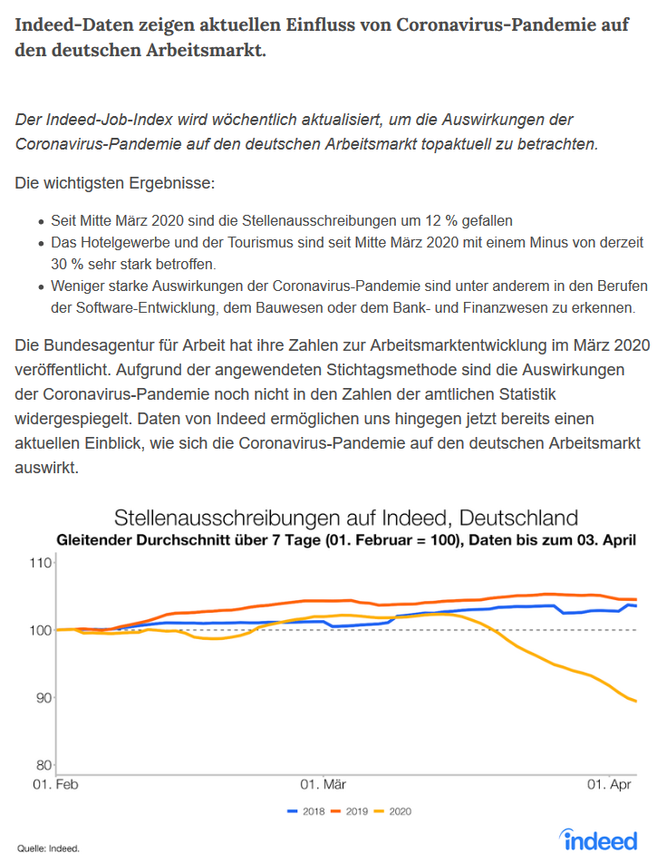

Source: <https://www.hiringlab.org/de/blog/2020/04/08/coronavirus-arbeitsmarkt-stellenausschreibungen/> (state of date 9th April 2020)

Figure : LinkedIn: How COVID-19 is impacting hiring around the world

|  |  |
| --- | --- |
|  |  |
|  | |

Source: <https://www.linkedin.com/pulse/how-covid-19-impacting-hiring-around-world-karin-kimbrough/?src=direct%2Fnone&veh=direct%2Fnone%7Cdirect%2Fnone>

Figure : Textkernel: Free access to timely graphs in the situation of Covid-19

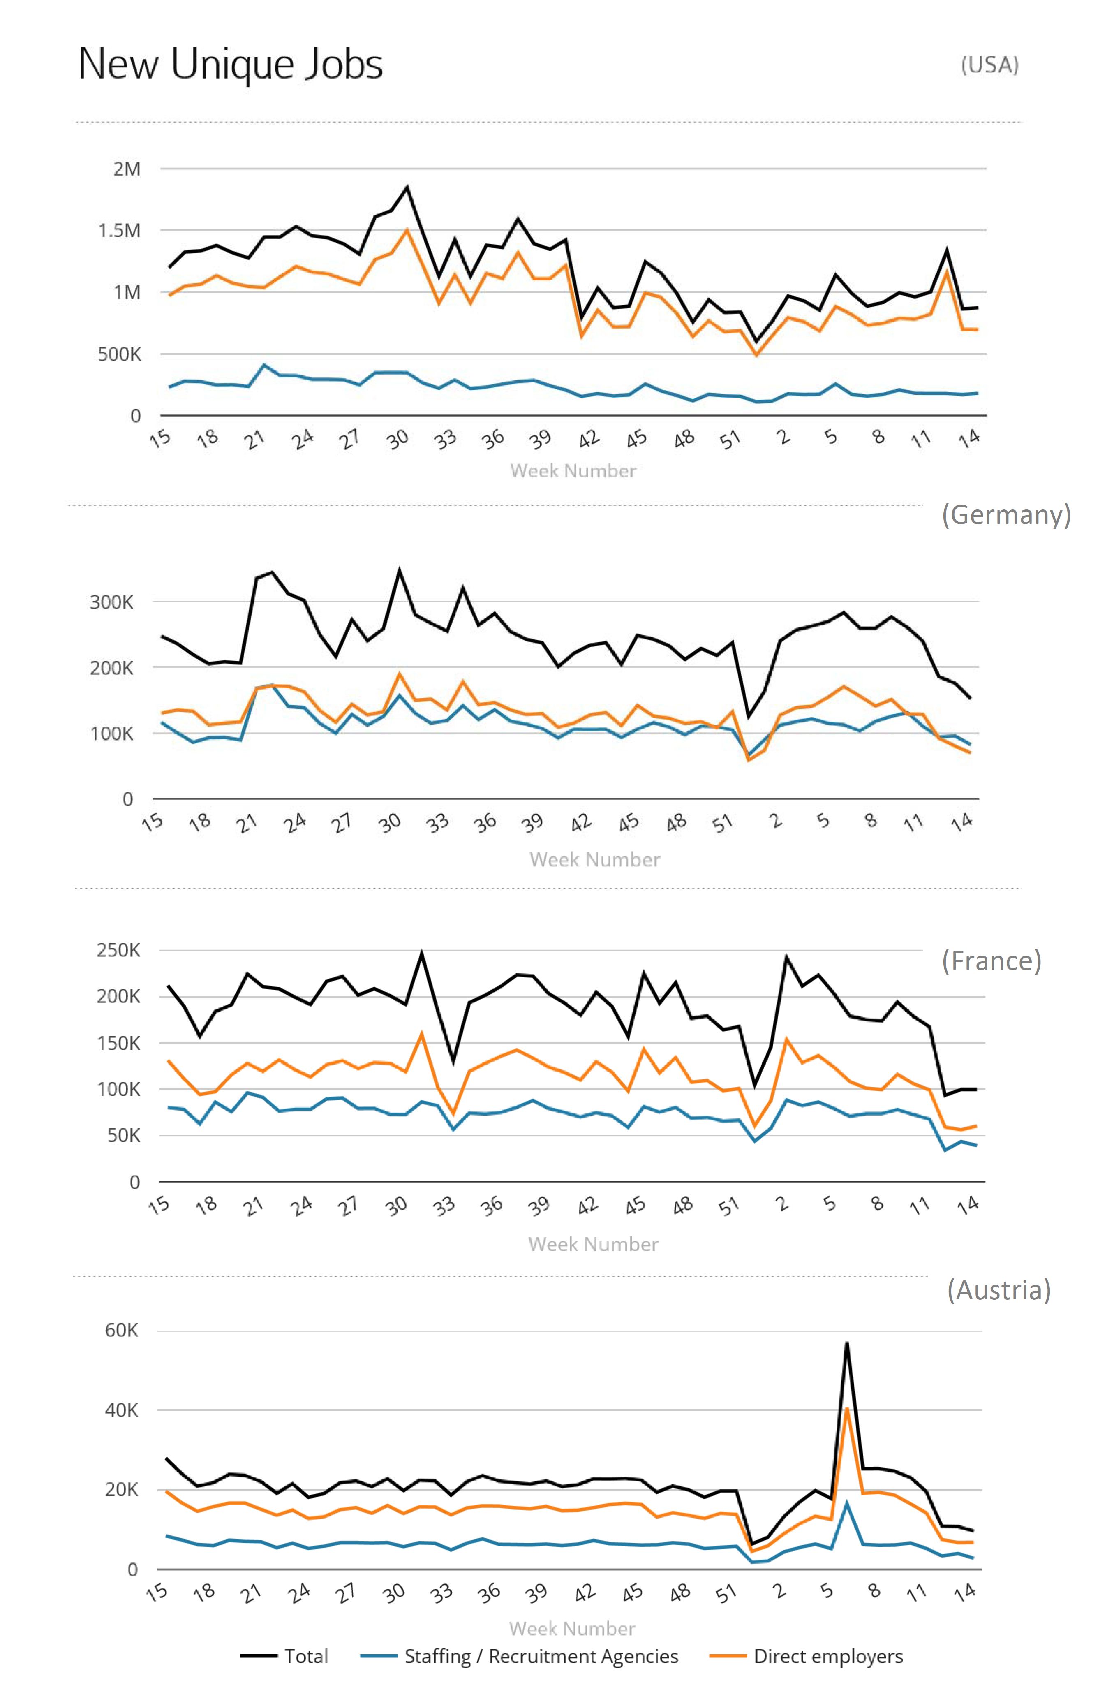

Source: Textkernel, see <https://www.jobfeed.de/home.php>, state of date: 07 April 2020.

Figure : Germany: how to interpret the different OJA indicators from selected private companies using the example of Covid-19

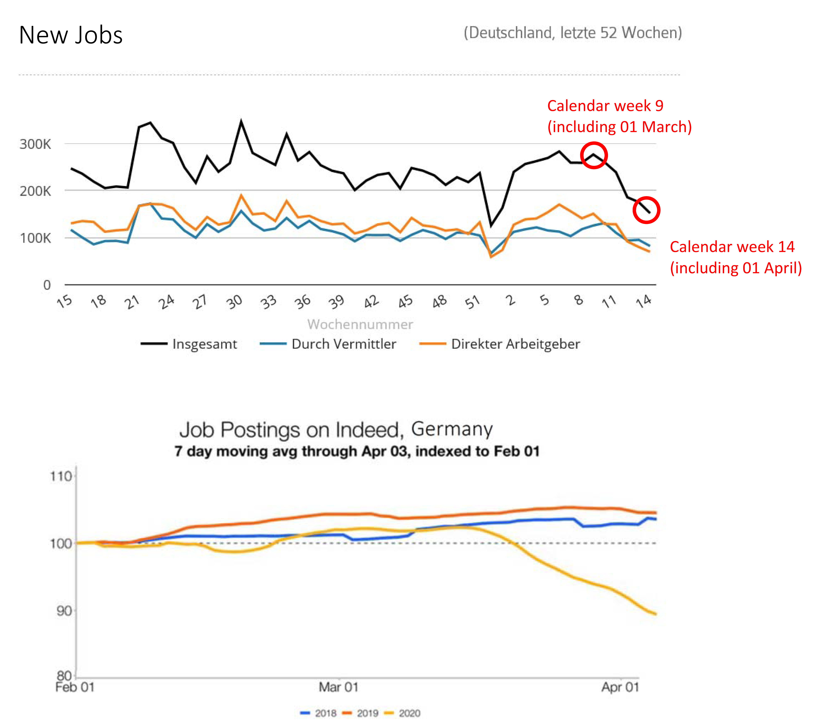

Sources:

* First graph from Textkernel, see <https://www.jobfeed.de/home.php>, state of date: 07 April 2020.
* Second graph from Indeed, see <https://www.hiringlab.org/de/blog/2020/04/08/coronavirus-arbeitsmarkt-stellenausschreibungen/>, State of date: 09 April 2020.

# Structural analyses

One of the most popular structural anaylsis is that on jobs and skills requested in online job advertisements. This is what for example CEDEFOP do with Skills-OVATE or Skills Panorama. They provide information on occupations, skills and regions based on international classifications: ISCO-08 for occupations, NUTS-2 for regions, ESCO version 1 for skills and NACE rev. 2 for sectors.

Regarding the Swiss Job Market Monitor there is another structural analysis of interest: the structural changes regarding the importance of different recruiting channels (see appendix Figure 13). Among other things, a distinction is made between company websites, online job portals and press. In this context, however, it would also be conceivable to analyse the changing importance of social media over time. However, in order to detect shifts from online job advertisements to social networks, it is necessary to collect not only OJA from job portals but also OJ postings from company websites and (other?) data from social networks.

In an earlier document, Germany has already proposed and described the calculation of a labour market concentration index (LMC) based on OJAs.[5] This is one idea for a more structural analysis. To measure such regional concentration, OJAs are broken down to Functional Urban Areas (FUA). These FUAs consists of city cores and their commuting zones. The LMC index can be published quarterly or yearly and can inform educational, regional and labour market policy.

**For a job portal owner** there are many other structural analyses possible, as they have access to much **more information than only on OJAs**. Many job portals have also data from the jobseekers, like information on job wishes or preferences, employment histories or complete resumes (CVs). They can also examine the search **behaviour of jobseekers**:

* WHAT? - Keywords such as "remote jobs" when entering a search
* Number of hits of job advertisements that meet certain criteria (e.g. "Remote Job")
* HOW? - Search intensity: Number of applications per jobseeker

Furthermore, they have data on submitted applications −at least within their own platform− and can therefore supply the following indicator as well:

* Number of applications per job/job advertisement

Job portal owner like LinkedIn do all this analyses[6] although they know that their data or not statistically representative. [7] In Germany the Institute for Employment Research (IAB – Institut für Arbeitsmarkt- und Berufsforschung) used those jobseeker information to analyse how the Corona crisis influences search processes on the labour market.[8] Even the ECB economists noted that LinkedIn's insights can provide "more timely information about labour market developments than that derived from more traditional statistical sources”. [9]

# Literature

Australian Government (2020), Vacancy Report June 2020, Release date: 22 July 2020. Available at <https://lmip.gov.au/PortalFile.axd?FieldID=2790176&.pdf> (state of date: 19th August 2020).

Bauer, Anja / Keveloh, Kristin / Mamertino, Mariano / Weber, Enzo (2020), Wie die Corona-Krise die Suchprozesse am Arbeitsmarkt beeinflusst, IAB-Forum 6 August 2020, available at: <https://www.iab-forum.de/wie-die-corona-krise-die-suchprozesse-am-arbeitsmarkt-beeinflusst/?pdf=17548> (state of date: 22 August 2020)

BLS (2020), Labor Force Statistics from the Current Population Survey, available at U.S. Bureau of Labor Statistics on <https://www.bls.gov/cps/cps_over.htm#faq> (state of date: 16th April 2020).

CEDEFOP (2019), Online job vacancies and skills analysis: a Cedefop pan-European approach, Luxembourg: Publications Office. Available at: [https://www.cedefop.europa.eu/  
files/4172_en.pdf](https://www.cedefop.europa.eu/files/4172_en.pdf) (state of date: 19th August 2020).

CEDEFOP (2018a). Real-time labour market information on skill requirements:setting up the EU system for online vacancy analysis. Global report. Available at: <https://www.cedefop.europa.eu/files/rlmi_-_skill_requirements_global_report.pdf> (state of date: 19th August 2020).

CEDEFOP (2018b), Mapping the landscape of online job vacancies. Background country report: Germany. Available at: <https://www.cedefop.europa.eu/files/rlmi_-_mapping_online_vacancies_germany.pdf> (state of date: 19th August 2020).

Descy, Pascaline / Kvetan, Vladimir / Zukersteinova, Alena / Wirthmann, Albrecht / Reis, Fernando (2018), Towards a Common Infrastructure for Online Job Vacancy Data, paper presented at DGINS Conference "The European path towards Trusted Smart Statistics" in Bucharest 2018. Available at <https://dgins2018.statisticsevents.ro/wp-content/uploads/2018/10/16-online-job-vacancies-v5-1.pdf> (state of date: 19th August 2020).

Chetty, Raj / Friedman, John N. / Hendren, Nathaniel / Stepner, Michael / The Opportunity Insights Team (2020), How Did COVID-19 and Stabilization Policies Affect Spending and Employment? A New Real-Time Economic Tracker Based on Private Sector Data NBER Working Paper No. 27431, June 2020 <http://www.nber.org/papers/w27431>

Conference Board (2020), News release #7015 Tuesday August 11, 2020, Online Labor Demand Rises in July, <https://conference-board.org/pdf_free/press/7015%20-%20HWOL%20July%202020.pdf> (state of date: 18 August 2020)

Conference Board (2018), The Conference Board Help Wanted OnLine® Technical Note, available at: [https://conference-board.org/pdf_free/press/  
2020%20HWOL%20Technical%20Note.pdf](https://conference-board.org/pdf_free/press/2020%20HWOL%20Technical%20Note.pdf) (state of date: 18th August 2020).

De Lazzer, Jakob (2020), Labour Market Concentration Indicators using Online Job Ad Data, document prepared for Workpackage WPB “Implementation – Online Job Vacancies” of the ESSnet on Big Data.*ESSnet internal document*

ECB (2020), High-frequency data developments in the euro area labour market, Prepared by Nicola Benatti, Vasco Botelho, Agostino Consolo, António Dias da Silva and Malgorzata Osiewicz, Published as part of the ECB Economic Bulletin, Issue 5/2020. The latter is available at <https://www.ecb.europa.eu/pub/pdf/ecbu/eb202005.en.pdf> (state of date: 18th August 2020).

Ifo Institute (2020), ifo Institute: Help Wanted – IT Service Providers and the Health Sector Need Employees in Germany, Press release June 16th 2020, available at <https://www.ifo.de/en/node/56091> (state of date: 18th August 2020).

LinkedIn Economic Graph (2019), AI Talent in the European Labour Market, available at: https://economicgraph.linkedin.com/content/dam/me/economicgraph/en-us/reference-cards/research/2019/LinkedIn-AI-Talent-in-the-European-Labour-Market.pdf.

Rengers, Martina (2018), Internetgestützte Erfassung offener Stellen – Machbarkeitsstudie im Rahmen eines ESSnet-Projekts zu Big Data, in WiSta 5/2018 S. 11ff. Available at <https://www.destatis.de/DE/Methoden/WISTA-Wirtschaft-und-Statistik/2018/05/internetgestuetzte-erfassung-052018.pdf?__blob=publicationFile&v=4> (state of date: 16th April 2020).

Sacchi (2014), Lange Messreihen zur Entwicklung des Stellenangebots der Schweizer Wirtschaft: Kombinierter Presse-Online-Index, SMM Working Paper 2014-1, Zürich. Available at <https://www.stellenmarktmonitor.uzh.ch/dam/jcr:00000000-4c97-2c4b-ffff-ffff9ef38383/SMM-WP-Sacchi_lange_Reihen_def.pdf> (state of date: 19th August 2020).

Sacchi, Stefan (2008), Adecco Swiss Job Market Index – Stellenmarktmonitor Schweiz, Methodische Grundlagen, Zürich. Available at <https://www.stellenmarktmonitor.uzh.ch/dam/jcr:ffffffff-ab27-3e8e-ffff-ffff98f1c6d9/ASJMI_Methoden.pdf> (state of date: 19th August 2020).

# Appendix

Figure : USA: Opportunity Insights Economic Tracker – Percent Change in weekly unique job postings by states

|  |
| --- |
|  |
| Change in weekly unique job postings, indexed to January 4-31 2020. This series is based on data from Burning Glass Technologies |

Source: <https://tracktherecovery.org/> (August 17th 2020)

Figure : USA: Opportunity Insights Economic Tracker – percent change in weekly unique job postings as time series

|  |
| --- |
|  |
| Change in weekly unique job postings, indexed to January 4-31 2020. This series is based on data from Burning Glass Technologies |

Source: <https://tracktherecovery.org/> (August 17th 2020)

Figure : Swiss Job Market Monitor: overall index and channel-specific sub-indices regarding specific recruiting channels

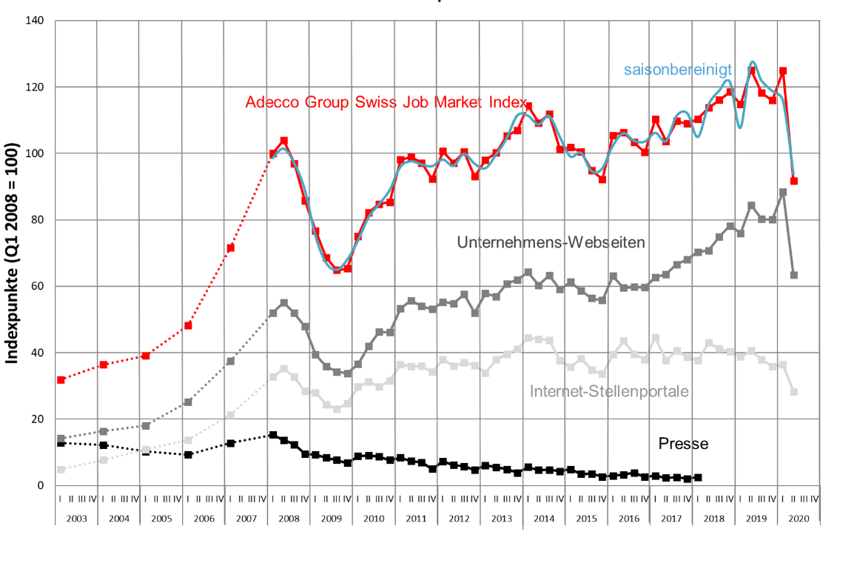

Source: <https://www.stellenmarktmonitor.uzh.ch/de/indices/asjmi.html> state of date: 19 August 2020

1. See Conference Board (2018) p. 3 and BLS (2020).
2. See Chetty et al. (2020) p. 1; words in the original are not printed in bold.
3. <https://www.x28.ch/jobradar/>.
4. See <https://www.burning-glass.com/research-project/covid-19/> (state of date 17th April 2020.
5. See de Lazzer (2020).
6. Publications on different analyses of LinkedIN can be found on <http://linkedin-deutschland.mynewsdesk.com/documents> (state of date: 22.08.2020).
7. LinkeIn mention the lack of representativity for example in one of their publications: “This analysis represents the world seen through the lens of LinkedIn data […] Although LinkedIn’s membership covers around 50 percent of Europe’s active labour force, its members are not evenly distributed across the EU. While the results are therefore not statistically representative, the digital and tech workforce tends to be well represented within our membership, even in countries where LinkedIn’s overall market share is smaller.” Methodology notes in LinkeIn Economic Graph (2919) p. 3
8. See Bauer et al. (2020).
9. ECB (2020) p. 56.